Game Design Document

Fill up the following document

1. Write the title of your project.

Who Ate My Cake?!

1. What is the goal of the game?

To defeat the other player.

1. Write a brief story of your game.

Two stick-men are blaming each other for stealing the cake! To settle the argument, they decided to do one thing – fight!

1. Which are the playing characters of this game?

* Playing characters are the ones who respond to the user based on the input from the user.
* Cars, monkeys, dinos, wizards, etc., are the playing characters in the game.

|  |  |  |
| --- | --- | --- |
| Number | Character Name | What can this character do? |
| 1 | Player 1 | Move and punch |
| 2 | Player 2 | Move and punch |
| 3 |  |  |
| 4 |  |  |
| 5 |  |  |
| 6 |  |  |
| 7 |  |  |
| 8 |  |  |

1. Which are the Non-Playing Characters of this game?

* Non-Playing characters are the ones that don't have an action or behavior when the user interacts with the game.
* Hurdles, stones, bananas, coins, etc., are non-playing characters in the game.

|  |  |  |
| --- | --- | --- |
| Number | Character Name | What can this character do? |
| 1 | Background | Nothing |
| 2 |  |  |
| 3 |  |  |
| 4 |  |  |
| 5 |  |  |
| 6 |  |  |
| 7 |  |  |
| 8 |  |  |

Draw your imagination of this game. What does this game look like?

* Draw the game either on your computer or on paper.
* Add images of the game scenes to show each of the playing and non-playing characters at least once.

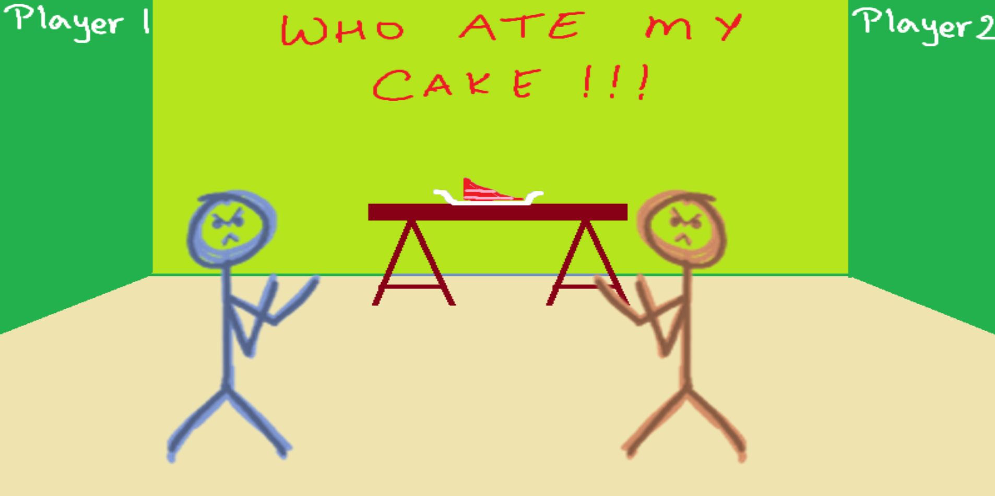

How do you plan to make your game engaging?

I can try and make my game as funny and challenging as possible.